Middle-to-End Rhyme

🔄 What is Middle-to-End Rhyme
# Source: Chatgpt (GPT-4-turbo) at [8/2/2025]
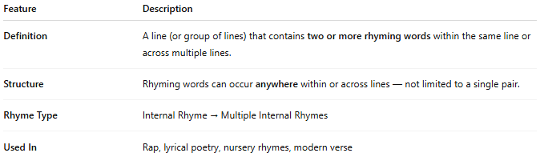
Feature | Description
Definition | A type of internal rhyme where a word in the middle of a line rhymes with the word at the end of the same line or a nearby line.
Structure | Common in both single lines and across couplets. Often used to create balance or symmetry.
Rhyme Type | Internal Rhyme → Middle-to-End Rhyme
Also Known As | Mid-line rhyme or mid-to-end rhyme

📝 Examples:
# Source: Chatgpt (GPT-4-turbo) at [8/2/2025]
The rain came down with a terrible pain.
He walked through fire to reach his desire.
They whispered in the night, fading out of sight.
Here, rain–pain, fire–desire, and night–sight are rhymes where the first word occurs mid-line and the second ends the line.

🎭 Effect in Poetry:
# Source: Chatgpt (GPT-4-turbo) at [8/2/2025]
- Creates sonic balance within a line
- Draws attention to internal structure
- Often more subtle than full end rhymes
- Enhances lyrical quality without rigid rhyme schemes

✅ When to Use:
# Source: Chatgpt (GPT-4-turbo) at [8/2/2025]
- To maintain flow and rhythm without predictable endings
- To surprise the reader with unexpected rhymes
- To smooth enjambment between thoughts or stanzas

